(Approx. 1758 words)

Cell Phone Photography
By Dick Maybach, Member, Brookdale Computer User Group, NJ
www.bcug.com
n2nd (at) att.net

Most cell-phone camera photos have little lasting value, making their quality unimportant. However, these cameras are rapidly improving, and more people are using them on vacations and at important events. It now becomes important to take the care to make their pictures worth showing, meaning you must now better understand your camera and its software. The quality of your photos depends more on your photographic skills than on your camera. Good photographers take good pictures regardless of their equipment, and those with limited ability take poor ones regardless of how much money they spend or the tonnage of gear they carry. Dedicated cameras can take better pictures, but they are usually kept safe at home, while our cell phones are almost always with us.

The first step is to recognize the limitations of cell phone cameras.
- Their shapes make them difficult to hold steady, especially while making adjustments.
- They have tiny sensors, making low-light photography difficult at best.
- They reside in pockets and purses, and their exposed lenses quickly become dirty.
- Their lenses are simple with fixed apertures and focal lengths.
Taking good pictures requires learning to compensate for these limitations.

Cell phones’ small display screens hide many sins. Develop the habit of transferring every image to a PC, whose large, high-resolution monitor allows you to see what you’ve captured, warts and all. Moving pictures to a PC also makes them available to image processing software and frees the limited storage space in your phone. Simple changes, such as cropping, exposure correction, and noise reduction, can make large differences.

You hold a conventional camera against your face with both hands. The viewfinder has optics that make the image appear to be about a meter from your eye, and there is an adjustment to compensate for aging vision. Compare this to a cell phone that you hold at arm’s length where its screen if often in direct sunlight. Clearly, the latter is subject to a lot more twitching, and using a selfie-stick makes this worse, creating blurry photos, especially in dim light. To minimize this hold your phone with both hands and release the shutter with a dedicated button (often one that controls the volume) rather than jabbing at the screen. Bend your arms so that your elbows are pressed against your waist or are resting on a table if you are sitting. In dim light, rest the phone against a solid object if possible. If your near vision is limited, hold the camera at arm’s length to make adjustments, but pull it closer to take the picture.

Tap the screen on the point where you want the camera to set its focus and exposure, otherwise it will make a choice. The result could be a sharply focused, well exposed shrub in the foreground and an overexposed blur in the background barely recognizable as the Leaning Tower of Pisa. If your subject is moving, set the camera to take a sequence of pictures; you’ll throw most of them away, but you may capture the moment you want. Also consider a sequence when photographing a group; you’ll have a better chance to catch everybody’s eyes open. Always squeeze the shutter button rather than jab at it; the latter jerks the camera. Taking a photo sequence means the timing is not important, so even here you can be gentle with the shutter.

The best compensation for a small sensor is to have plenty of light when you take the picture. You can sometimes achieve this my moving so the light source is behind you; certainly try to avoid back-lit subjects. Another approach is to limit the exposure sensitivity, which the camera sets by adjusting its ISO, although not all photo apps and phones allow this,. For my phone, ISO values above a few hundred produce very noisy images, which even capable photo processing software can’t correct. Once you limit the ISO, you will find you have long exposure times, which means you now must place the camera on a solid support to reduce the shake. You probably also want to delay the exposure, so that it takes place a few seconds after you press the button, giving you time to ensure the camera is steady. Again, not all camera apps have this feature.

Carry a clean, soft cloth or a packet of lens cleaning paper and use it often to clean the lens. Also, keep in mind that the lens is right at the surface of the case and has no shade. You may have to use your hand to keep sunlight from striking it directly. Let’s see now, you are holding the phone with one hand, operating the controls with another, and shading the lens with a third, while all the time trying to hold it steady. A shutter delay may help, but some thinking may be better. Perhaps you can stand in the shade or ask someone to cast a shadow on your camera.

The simple lens is always set for wide-angle pictures; it achieves a telephoto effect by throwing away the outer portions of the image. As a result, you should avoid using the camera’s zoom feature, instead move closer to your subject. If you can’t, then take the picture at wide angle and throw away the unwanted portion of the image with processing software after you move it to your PC. This gives you more flexibility on what you choose in include the finished photo. Figure 1 shows a picture taken in normal (wide-angle) mode.

Figure 1. Image in Wide-angle Mode.

Figure 2 shows the same image taken using the zoom feature. The camera throws away the portion of shown in red; however it processes the image so that it has the same number of pixels before it stores the file. If you enlarge two images of the same scene, one wide-angle and one zoomed (you’ll of course have to magnify the wide-angle one more), you will see that both have about the same resolution, meaning the added pixels in the zoomed image have not improved its quality. Now do the same experiment, but instead of zooming, move closer to your subject, and you’ll find that the latter image does have more detail.

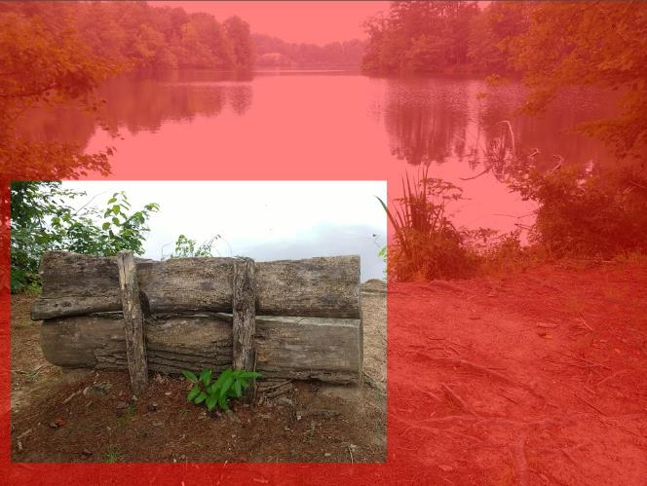Figure 2. A Zoomed Image.

Finally, be aware that unlike a dedicated camera, a cell phone camera has a fixed aperture; it controls exposure only by adjusting the ISO and exposure time. As a result, you have little control of the depth-of-field. However, because a cell-phone camera has a small sensor, its depth-of-field is large, making it a concern only when you are very close to your subject.

Most photo apps have features you can use to improve your pictures. Figure 3 shows the default display for Moto Camera, the photo app supplied with my Motorola phone. Note the rule-of-thirds guide lines, which help to compose your photo. A common technique is to locate the main subject at one of the intersections. Some apps give you a choice of several such composing aids. Note also the yellow icon around the subject, which appears because I tapped the screen there to create a focus and exposure point. This app also allows you to adjust the exposure by moving the white spot around the icon circle. The other visible controls are (on the left) set manual or automatic mode, set the delay, control the flash, take a high-dynamic-range photo, and (on the right) select movie, still, or panoramic mode, and switch between the front and back cameras. The large white button on the right is the on-screen shutter release.

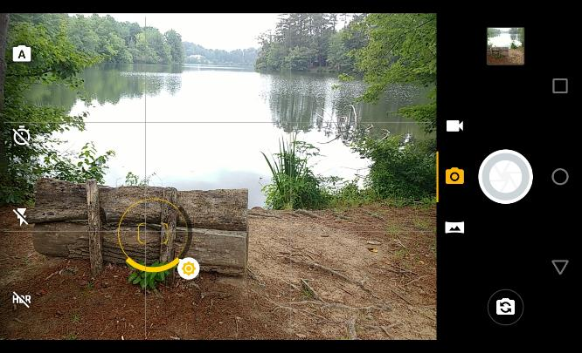Figure 3. Moto Camera Display.

Surprisingly, I found the photo app supplied with my phone (available from the Play Store as Moto Camera) to be the one I use most often. It allows for adjusting the focus, white balance, shutter speed. ISO, and exposure, includes an exposure delay, high-dynamic-range (HDR), panoramas, and can disable the flash. It doesn’t allow photo sequences, and I use Open Camera for this feature.

Figure 4 shows the manual mode of Moto Camera, which allows considerable flexibility. The controls are, from left to right: focus, white balance, shutter speed, ISO, and exposure compensation. You move the white circles to make adjustments. Except for exposure compensation, a white dot at the bottom of its arc means that adjustment is automatic.

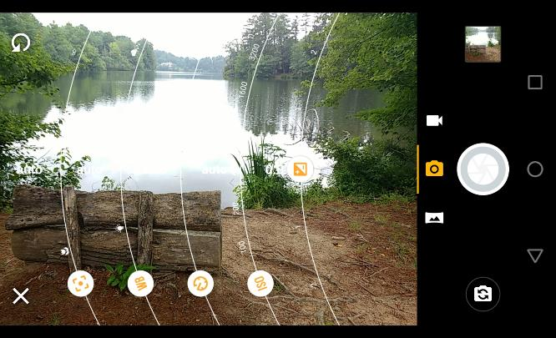Figure 4. Moto Camera in Manual Mode.

Many apps offer high dynamic range (HDR) where they take several photos at different exposures and combine them with the goal of showing details in both the very bright and the very dim areas. In my experience, it is very difficult to obtain acceptable HDR results, even with a professional camera and high-quality photo processing software. The results with a phone camera and its app software are often disappointing, but you have nothing to lose by trying. The technique won’t work on moving subjects; even leaves moving in the background will cause problems. Some apps, for example Open Camera (available from the Play Store), have a dynamic range optimization (DRO), which processes the shadow and highlight areas differently in a single image. This works for moving subjects and I’ve found the improvement often approaches that using HDR. Open Camera will also save the individual images it combines into an HDR one, which enables you to use your PC processing software and perhaps get better results than with the app’s software.

The capabilities of a photo app depend on the version of Android under which it runs and on what features the vendor has enabled. To get everything you need, you will have to experiment and probably install more than one photo app.

We can summarize this discussion as follows.
- Hold the camera firmly with both hands and use a dedicated button to release the shutter and squeeze rather than jab at it.
- Brace your elbows and in low light rest the camera on a firm support. Consider using a shutter delay to reduce camera jiggle.
- Minimize using the zoom feature but take your pictures at wide angle.
- Always select the focus point.
- Keep your lens clean, and shade it from direct sunlight.
- Look at your images on a large, high-resolution monitor.
- Experiment with camera apps to find those that best suit you and your phone.

With a little care and practice you can take surprisingly high-quality photos with your cell-phone camera, often approaching those from dedicated cameras and far surpassing those from cameras of just a few years ago.

